|  |  |
| --- | --- |
|  | **LDCW6123 FUNDAMENTALS OF DIGITAL COMPETENCE FOR PROGRAMMERS**  Trimester 2, 2023/2024 |

**GROUP PROJECT**

**Tutor: Mr. Muhammad Arif Bin Hassan**

**Tutorial Group: 1A**

*Prepared by:*

|  |  |  |
| --- | --- | --- |
| **Student ID** | **Student Name** | **Phone number** |
| 1231302716 | SOOTHI KEE JOTHI A/P RAJENDRAM | 016-6812027 |
| 1231301245 | GUNA SUREYAH A/L GUNA CHANDRAN | 016-3987128 |
| 1231302640 | CHONG KAI YUN | 011-10598581 |
| 1221101811 | KIMBERLIE R.SEQUERAH | 011-51310031 |
| 1231301358 | CHIN JET NING | 011-19116706 |

**Declaration by group leader**

I hereby declare that all group members’ names are correctly included in the above section. I hold a copy of this assignment which I can produce if the original is lost or damaged. I certify that no part of this assignment has been copied from any other student’s work or from any other source except where due acknowledgement is made in the assignment.

Group leader’s signature : Group leader’s name : SOOTHI KEE JOTHI A/P RAJENDRAM Group leader’s student ID 1231302716

Date : 1/6/2024

**Group member declaration**

*(Each group member, including the* ***group leader****, must individually fill up and submit this form)*

Group member’s name : SOOTHI KEE JOTHI A/P RAJENDRAM

For the purpose of completing this assignment, I have performed the following tasks (please list):

* Have assigned the task for group members
* Have completed the mobile app user manual.
* Have completed the video presentation
* Have completed the Git & Github part

*I hereby declare that I have assessed this submission and I take full responsibility should there be any inaccuracies, incompleteness, omissions, delays or non-submission.*

Group member’s signature :

Group member’s name : SOOTHI KEE JOTHI A/P RAJENDRAM

Group member’s ID 1231302716

Group member’s tel. no. : 016-6812027

Group member’s email : [1231302716@student.mmu.edu.my](mailto:1231302716@student.mmu.edu.my)

Date : 1/6/2024

**Group member declaration**

*(Each group member, including the* ***group leader****, must individually fill up and submit this form)*

Group member’s name : GUNA SUREYAH A/L GUNA CHANDRAN

For the purpose of completing this assignment, I have performed the following tasks (please list):

* Have completed the figma app prototype
* Had discussion with members about the project idea.
* Have participated in the video presentation.

*I hereby declare that I have assessed this submission and I take full responsibility should there be any inaccuracies, incompleteness, omissions, delays or non-submission.*

Group member’s signature :

Group member’s name : GUNA SUREYAH A/L GUNA CHANDRAN

Group member’s ID 1231301245

Group member’s tel. no. : 016-3987128

Group member’s email : [1231301245@student.mmu.edu.my](mailto:1231301245@student.mmu.edu.my)

Date : 1/6/2024

**Group member declaration**

*(Each group member, including the* ***group leader****, must individually fill up and submit this form)*

Group member’s name : CHONG KAI YUN

For the purpose of completing this assignment, I have performed the following tasks (please list):

* Have completed the website site map.
* Had discussion with group members about the project
* Had completed building the website.
* Have participated in the video presentation.

*I hereby declare that I have assessed this submission and I take full responsibility should there be any inaccuracies, incompleteness, omissions, delays or non-submission.*

Group member’s signature :

Group member’s name : CHONG KAI YUN

Group member’s ID 1231302640

Group member’s tel. no. : 011-1059851

Group member’s email : [1231302640@student.mmu.edu.my](mailto:1231302640@student.mmu.edu.my)

Date : 1/6/2024

**Group member declaration**

*(Each group member, including the* ***group leader****, must individually fill up and submit this form)*

Group member’s name : KIMBERLIE R.SEQUERAH

For the purpose of completing this assignment, I have performed the following tasks (please list):

* Had completed the part in making the figma app prototype
* Have participated in the video presentation
* Give some ideas about the idea of the assignment

*I hereby declare that I have assessed this submission and I take full responsibility should there be any inaccuracies, incompleteness, omissions, delays or non-submission.*

Group member’s signature :

Group member’s name : KIMBERLIE R.SEQUERAH

Group member’s ID 1221101811

Group member’s tel. no. : 011-51310031

Group member’s email : [1221101811@student.mmu.edu.my](mailto:1221101811@student.mmu.edu.my)

Date : 1/6/2024

**Group member declaration**

*(Each group member, including the* ***group leader****, must individually fill up and submit this form)*

Group member’s name : CHIN JET NING

For the purpose of completing this assignment, I have performed the following tasks (please list):

* Have completed building the website.
* Have participated in building the website.
* Have given some ideas while doing the project.

*I hereby declare that I have assessed this submission and I take full responsibility should there be any inaccuracies, incompleteness, omissions, delays or non-submission.*

Group member’s signature :

Group member’s name : CHIN JET NING

Group member’s ID 1231301358

Group member’s tel. no. : 011-19116707

Group member’s email : [1231301358@student.mmu.edu.my](mailto:1231301358@student.mmu.edu.my)

Date : 1/6/2024

**Table of Content**

Website URL Link…………………………………………………………………………...8

Figma URL Link……………………………………………………………………………..9

Mobile App User Manual……………………………………………………………………10

Website Site Map…………………………………………………………………………….13

Website Screenshot…………………………………………………………………………..14

Mobile App Screenshot………………………………………………………………………17

Video Presentation Link……………………………………………………………………..21

Own Peer Evaluation Form………………………………………………………………….22

GitLog………………………………………………………………………………………..27

**Website URL Link**

Website Link: <https://five5high.wixsite.com/five5high>

**Figma URL Link**

<https://www.figma.com/design/EGxda2YKEuAjVtqZBN050o/Shop-Ui-(Community)?node-id=0-1&t=d6tBkrNT99JQ7XJ7-1>

**Mobile App User Manual**

**Five5High App User Manual Page 1**

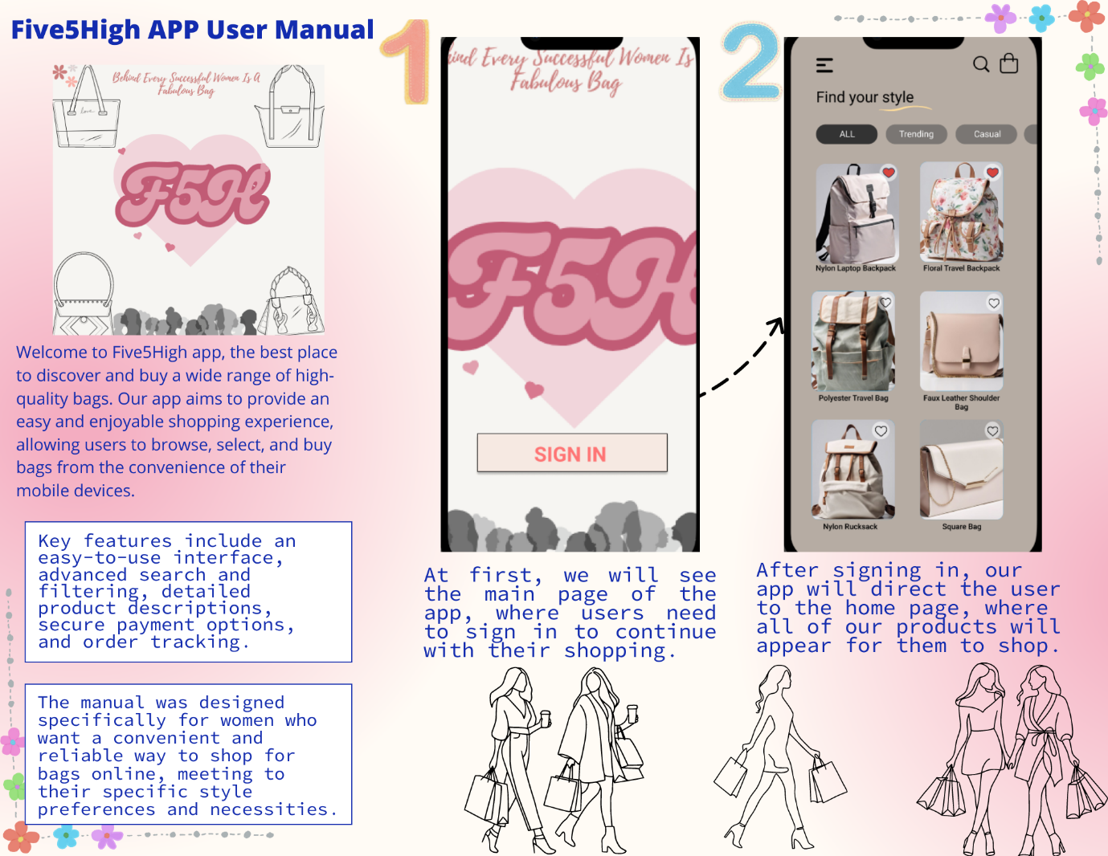

**Five5High App User Manual Page 2**

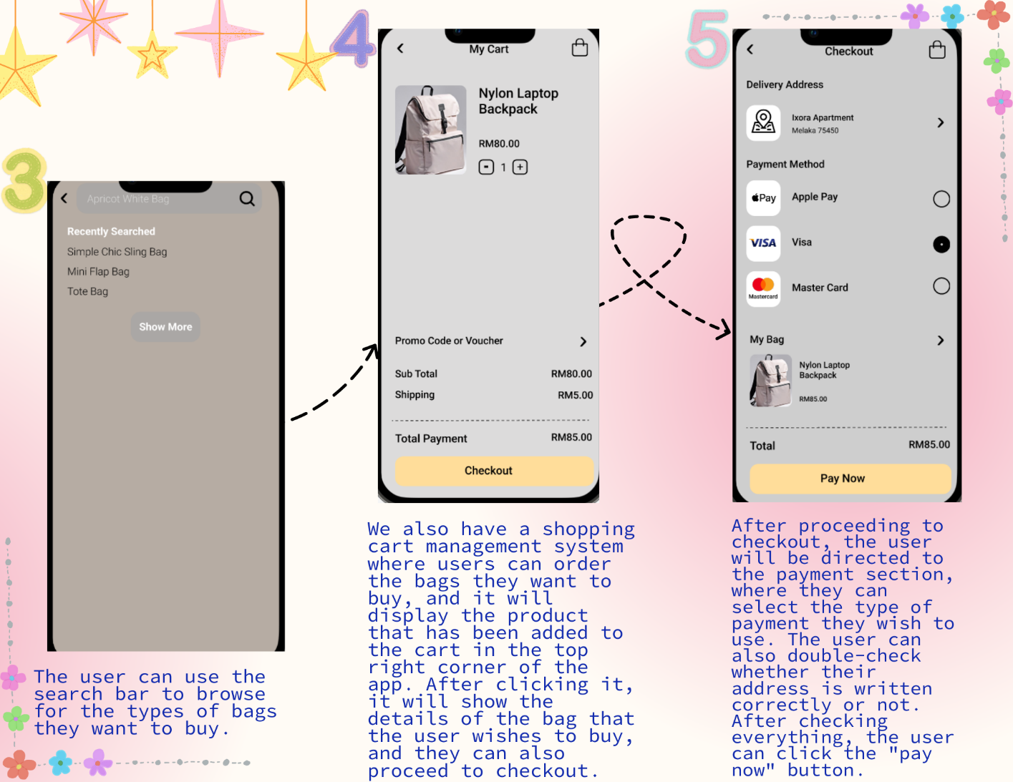

**Five5High App User Manual page 3**

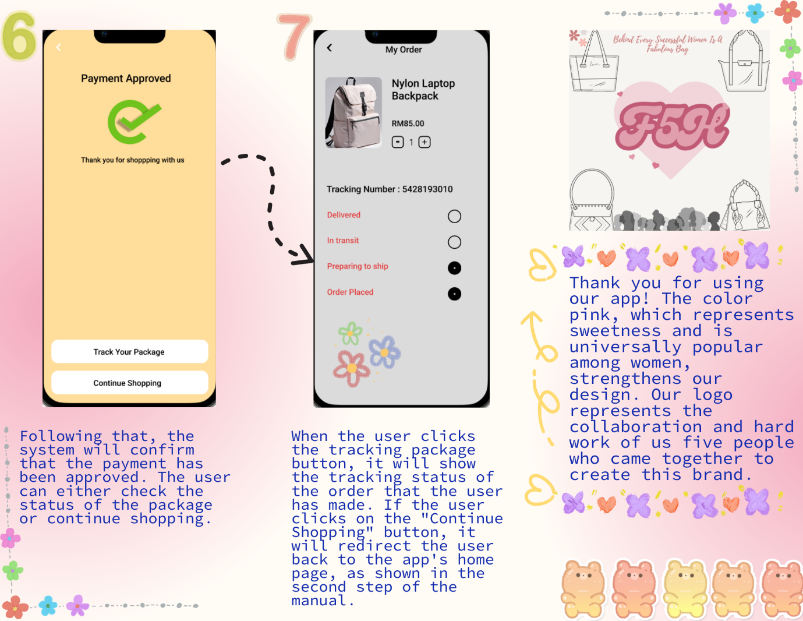

**Website Site Map**

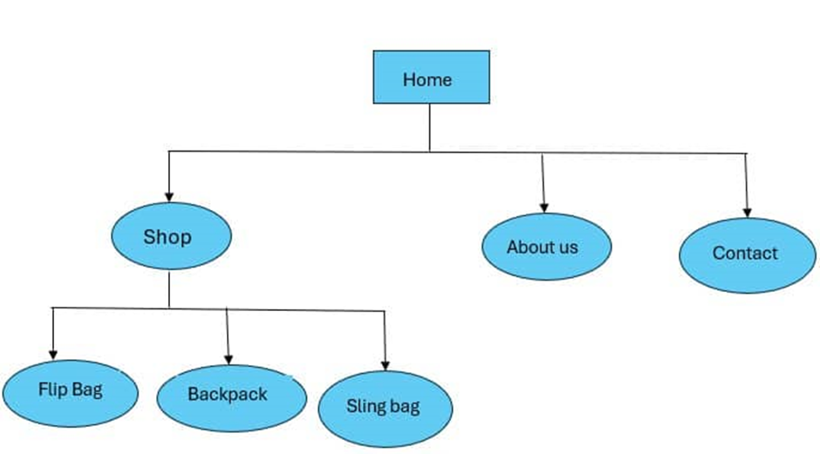

**Website Screenshot**











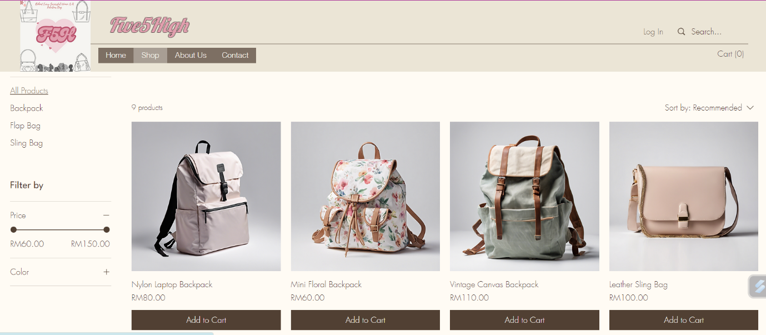

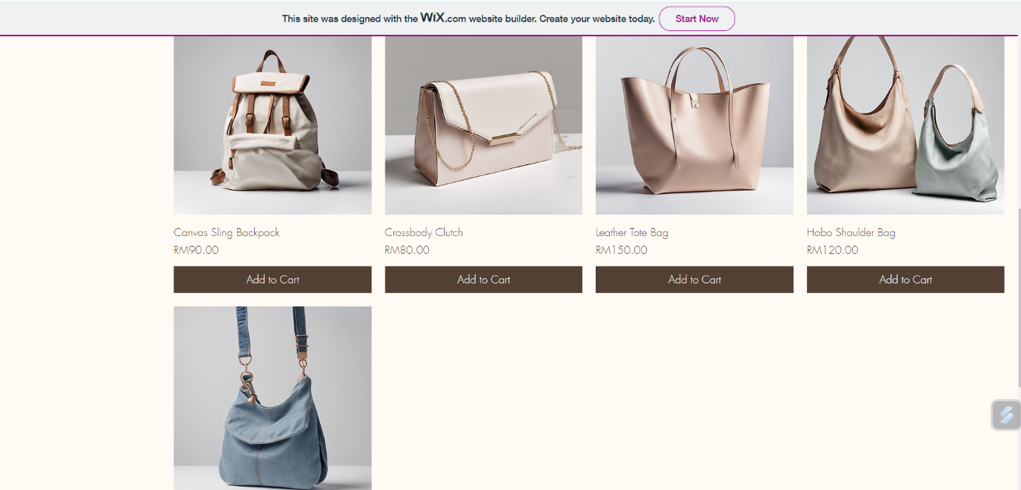

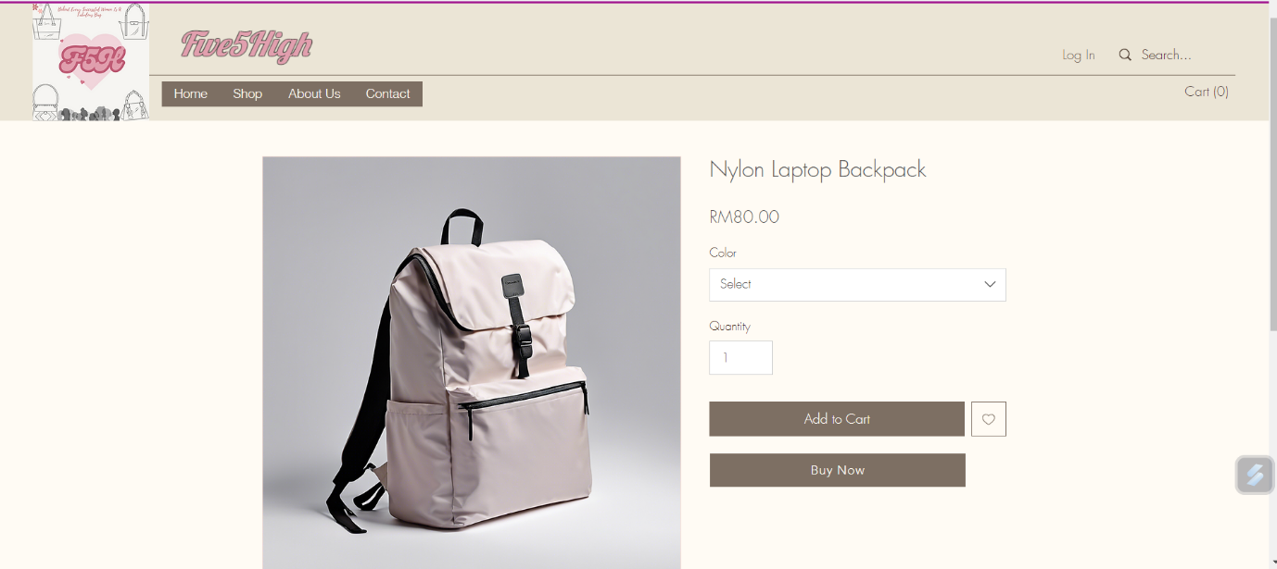

**Mobile App Screenshot**



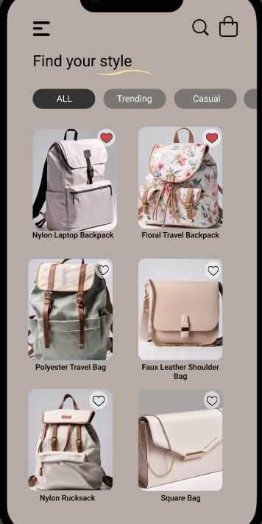

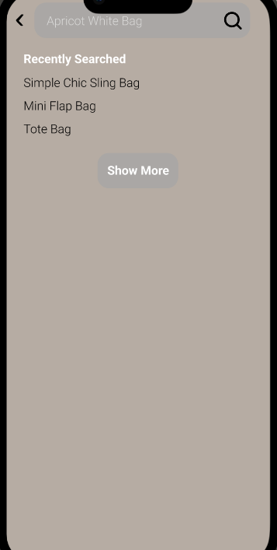

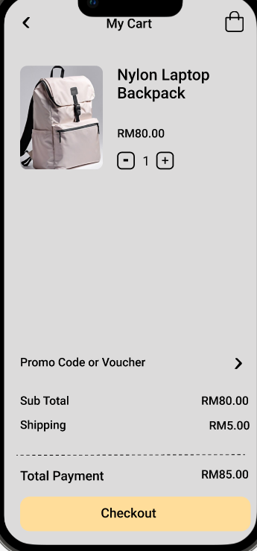

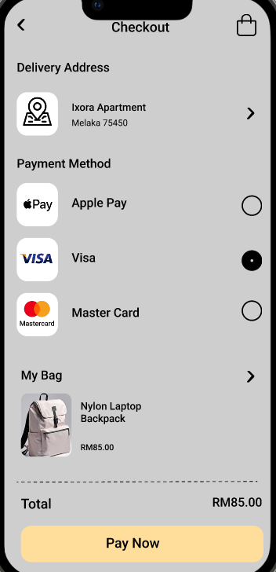

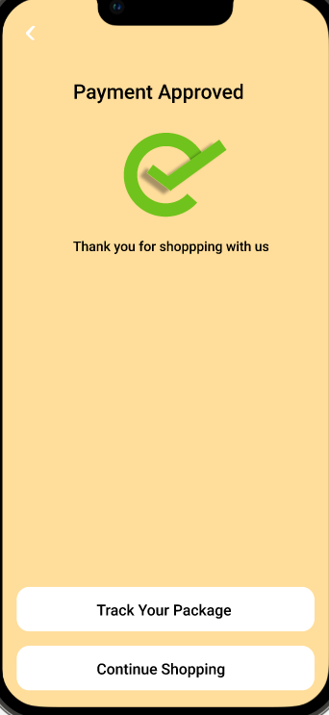

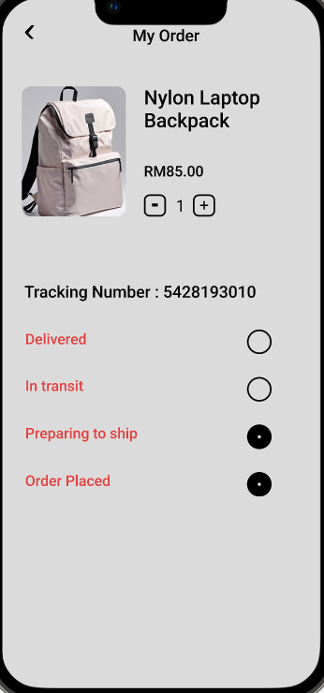

**Video Presentation Link**

<https://www.youtube.com/watch?v=uLttQd71xsI>

**Peer Evaluation Form**

LDCW6123 FUNDAMENTALS OF DIGITAL COMPETENCE FOR PROGRAMMERS

SELF PEER EVALUATION

**INSTRUCTIONS:**

Assess each member of your group, including yourself, using the form below. Write your group member’s names across the top including your own, and then rate each person in the categories using the number system below. This evaluation is done anonymously. Be honest with yourself and in evaluating others. Submit this evaluation personally to your group leader.

Rating scale: Poor - 1

Below average - 2

Average - 3

Above average - 4

Superior - 5

|  |  |  |  |  |  |  |
| --- | --- | --- | --- | --- | --- | --- |
| Evaluation Criteria | Your name:  Soothi Kee Jothi A/P Rajendram | Member 1  Guna Sureyah A/L Guna Chandran | Member 2  Chong Kai Yun | Member 3  Kimberlie R.Sequerah | Member 4  Chin Jet Ning | Member 5 |
| Attend group meeting regularly and arrive on time. | 5 | 5 | 5 | 5 | 5 |  |
| Participate/Contribute meaningfully to groudiscussion. | 5 | 5 | 5 | 5 | 5 |  |
| Prepare task assigned in a quality manner. | 5 | 5 | 5 | 5 | 5 |  |
| Demonstrate a cooperative and supportive attitude to all team members. | 5 | 5 | 5 | 5 | 5 |  |
| Total : | 20/20 | 20/20 | 20/20 | 20/20 | 20/20 | /20 |

LDCW6123 FUNDAMENTALS OF DIGITAL COMPETENCE FOR PROGRAMMERS

SELF PEER EVALUATION

**INSTRUCTIONS:**

Assess each member of your group, including yourself, using the form below. Write your group member’s names across the top including your own, and then rate each person in the categories using the number system below. This evaluation is done anonymously. Be honest with yourself and in evaluating others. Submit this evaluation personally to your group leader.

Rating scale: Poor - 1

Below average - 2

Average - 3

Above average - 4

Superior - 5

|  |  |  |  |  |  |  |
| --- | --- | --- | --- | --- | --- | --- |
| Evaluation Criteria | Your name:    GUNA SUREYAH | Member 1 SOOTHI KEE JOTHI A/P RAJENDRAM | Member 2  CHONG KAI TUN | Member 3  KIMBERLIE R.SEQUERAH | Member 4  CHIN JET NING | Member 5 |
| Attend group meeting regularly and arrive on time. | 5 | 5 | 5 | 5 | 5 |  |
| Participate/Contribute meaningfully to groudiscussion. | 5 | 5 | 5 | 5 | 5 |  |
| Prepare task assigned in a quality manner. | 5 | 5 | 5 | 5 | 5 |  |
| Demonstrate a cooperative and supportive attitude to all team members. | 5 | 5 | 5 | 5 | 5 |  |
| Total : | 20/20 | 20/20 | 20/20 | 20/20 | 20/20 | /20 |

LDCW6123 FUNDAMENTALS OF DIGITAL COMPETENCE FOR PROGRAMMERS

SELF PEER EVALUATION

**INSTRUCTIONS:**

Assess each member of your group, including yourself, using the form below. Write your group member’s names across the top including your own, and then rate each person in the categories using the number system below. This evaluation is done anonymously. Be honest with yourself and in evaluating others. Submit this evaluation personally to your group leader.

|  |  |  |
| --- | --- | --- |
| Rating scale: | Poor | - 1 |
|  | Below average | - 2 |
|  | Average | - 3 |
|  | Above average | - 4 |
|  | Superior | - 5 |

|  |  |  |  |  |  |  |
| --- | --- | --- | --- | --- | --- | --- |
| Evaluation Criteria | Your name: Chong Kai Yun | Member 1 Guna Sureyah A/L Guna Chandran | Member 2 Soothi Kee Jothi A/P Rajendram | Member 3 Kimberlie R.Sequerah | Member 4 Jetning Chin | Member 5 |
| Attend group meeting regularly and arrive on time. | 5 | 5 | 5 | 5 | 5 |  |
| Participate/Contribute meaningfully to groudiscussion. | 5 | 5 | 5 | 5 | 5 |  |
| Prepare task assigned in a quality manner. | 5 | 5 | 5 | 5 | 5 |  |
| Demonstrate a cooperative and supportive attitude to all team members. | 5 | 5 | 5 | 5 | 5 |  |
| Total : | 20 /20 | 20/20 | 20/20 | 20/20 | 20/20 | /20 |

LDCW6123 FUNDAMENTALS OF DIGITAL COMPETENCE FOR PROGRAMMERS

SELF PEER EVALUATION

**INSTRUCTIONS:**

Assess each member of your group, including yourself, using the form below. Write your group member’s names across the top including your own, and then rate each person in the categories using the number system below. This evaluation is done anonymously. Be honest with yourself and in evaluating others. Submit this evaluation personally to your group leader.

Rating scale: Poor - 1

Below average - 2

Average - 3

Above average - 4

Superior - 5

|  |  |  |  |  |  |  |
| --- | --- | --- | --- | --- | --- | --- |
| Evaluation Criteria | Your name:  Kimberlie R. Sequerah | Member 1  Soothi Kee Jothi A/P Rajendram | Member 2  Chong Kai Yun | Member 3  Guna Sureyah A/L Guna Chandran | Member 4  Chin Jet Ning | Member 5  - |
| Attend group meeting regularly and arrive on time. | 5 | 5 | 5 | 5 | 5 | - |
| Participate/Contribute meaningfully to groudiscussion. | 5 | 5 | 5 | 5 | 5 | - |
| Prepare task assigned in a quality manner. | 5 | 5 | 5 | 5 | 5 | - |
| Demonstrate a cooperative and supportive attitude to all team members. | 5 | 5 | 5 | 5 | 5 | - |
| Total : | 20/20 | 20/20 | 20/20 | 20/20 | 20/20 | -/20 |

LDCW6123 FUNDAMENTALS OF DIGITAL COMPETENCE FOR PROGRAMMERS

SELF PEER EVALUATION

**INSTRUCTIONS:**

Assess each member of your group, including yourself, using the form below. Write your group member’s names across the top including your own, and then rate each person in the categories using the number system below. This evaluation is done anonymously. Be honest with yourself and in evaluating others. Submit this evaluation personally to your group leader.

|  |  |  |
| --- | --- | --- |
| Rating scale: | Poor | - 1 |
|  | Below average | - 2 |
|  | Average | - 3 |
|  | Above average | - 4 |
|  | Superior | - 5 |

|  |  |  |  |  |  |
| --- | --- | --- | --- | --- | --- |
| Evaluation Criteria | Your name:  CHIN JET NING | Member 1  SOOTHI KEE JOTHI A/P RAJENDRAM | Member 2  CHONG KAI YUN | Member 3  GUNA SUREYAH A/L GUNA CHANDRAN | Member 4  KIMBERLIE RACHEL SEQUERAH |
| Attend group meeting regularly and arrive on time. | 5 | 5 | 5 | 5 | 5 |
| Participate/Contribute meaningfully to groudiscussion. | 5 | 5 | 5 | 5 | 5 |
| Prepare task assigned in a quality manner. | 5 | 5 | 5 | 5 | 5 |
| Demonstrate a cooperative and supportive attitude to all team members. | 5 | 5 | 5 | 5 | 5 |
| Total : | 20/20 | 20/20 | 20/20 | 20/20 | 20/20 |

**Git Log**

First, create a directory, Next, change the directory and initialize it.

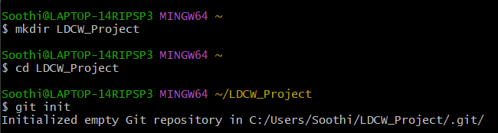

After that, we need to add the file that is inside the directory we created.

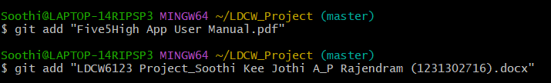

After adding it, we need to commit it with a descriptive message.

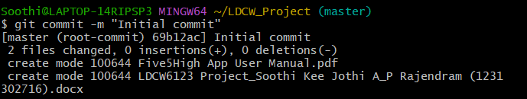

We need to make sure we have a GitHub account. If we have an account, we can simply link it to GitHub by entering our username. Another step is to link it to our email address.

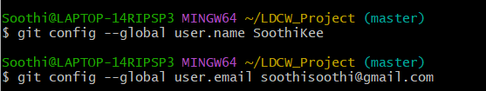

After linking it, we'll return to GitHub and create a new repository. After creating it, we'll need to copy the link below.

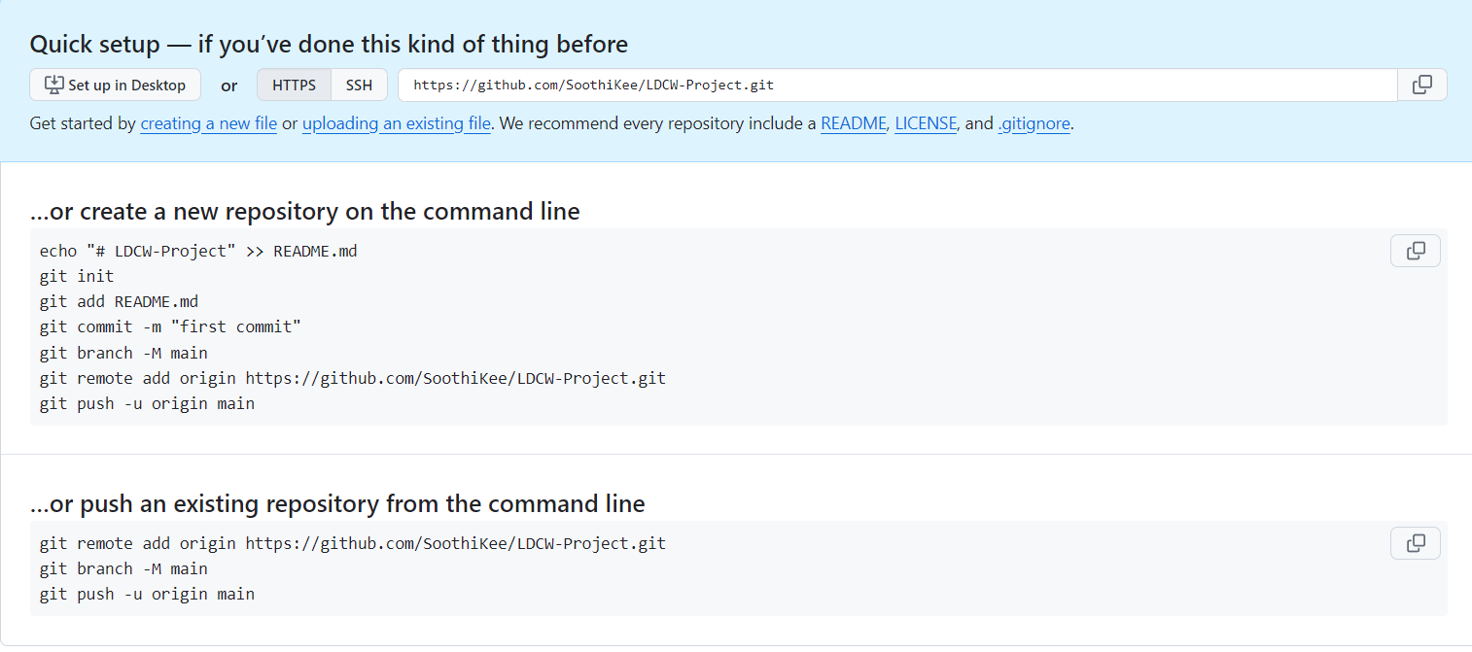

Then we go back to git bash and paste the URL link that we copied.



Next, we push to the master branch. After pushing it, we will see the files in the GitHub repository that we created.

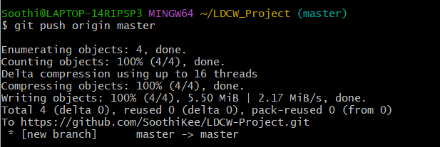

Now, we will create a new branch and switch to the new branch. After we’ve made our changes, stage them with git add and commit them with a descriptive message. Then we will push the branch to GitHub.

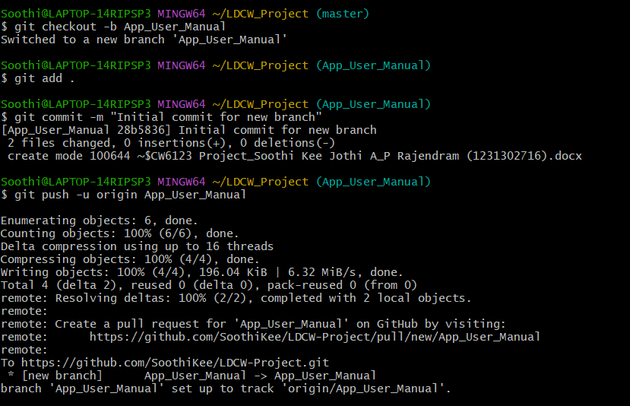

After that, we need to visit our GitHub repository page. It will show a banner suggesting to “Compare & pull request” for our new branch. So, we need to click on it to verify it.

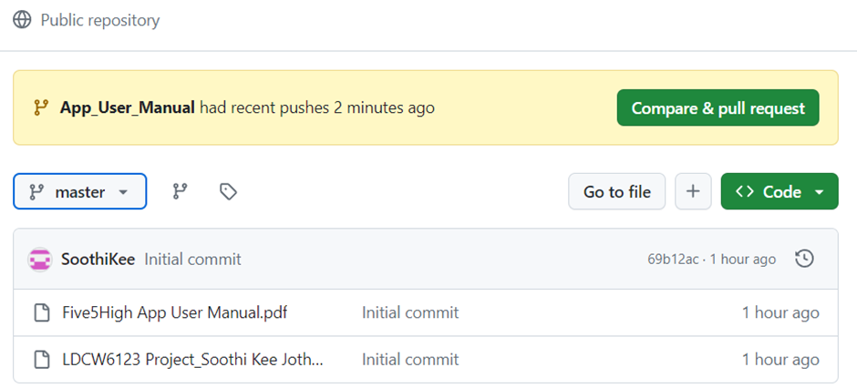

After verifying it, we will only need to create the pull request. We can also change the title. 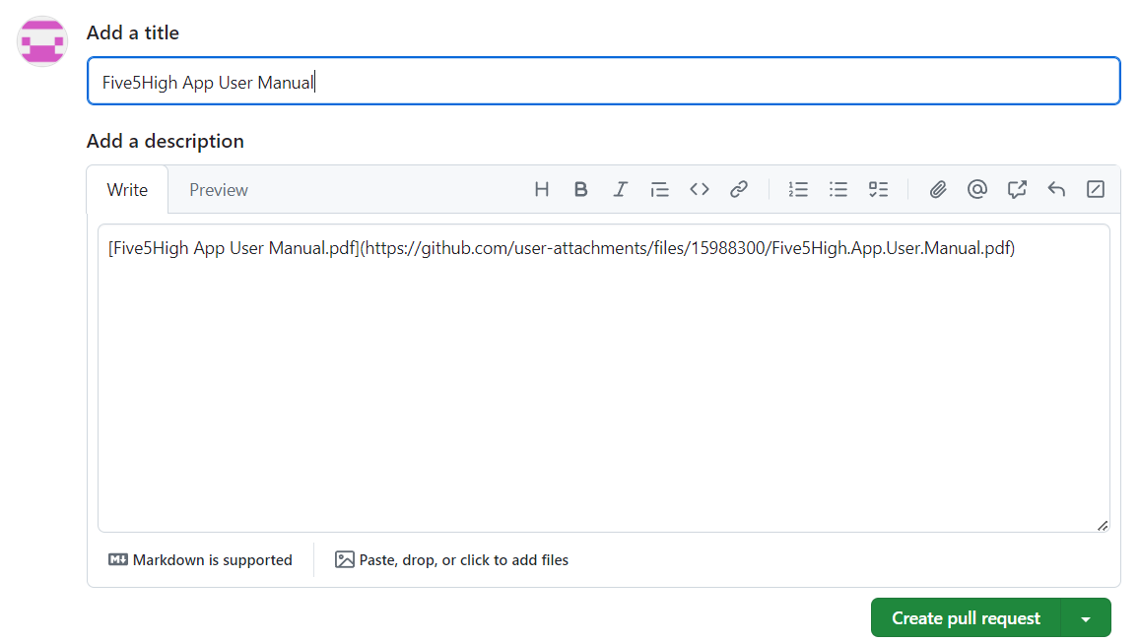

After that we will see that it is created.

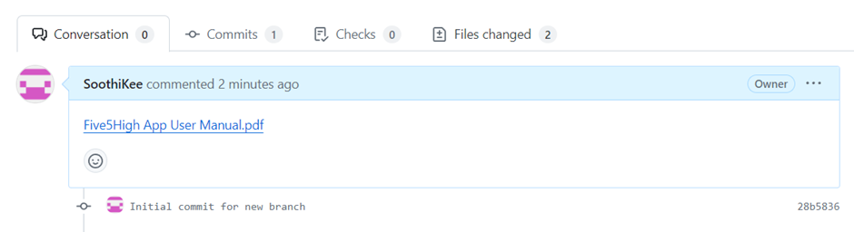

Then we will see that the master branch and the new branch are inside the GitHub repository.

